**Tower Of Hanoi**

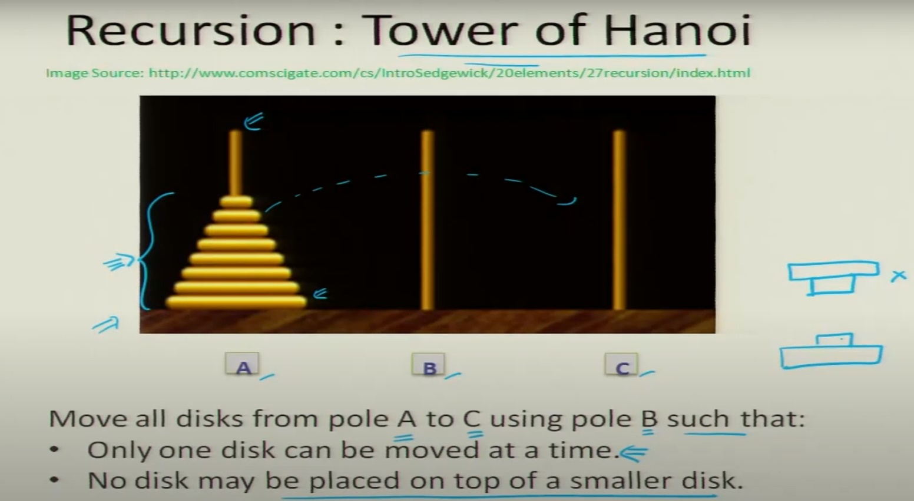

[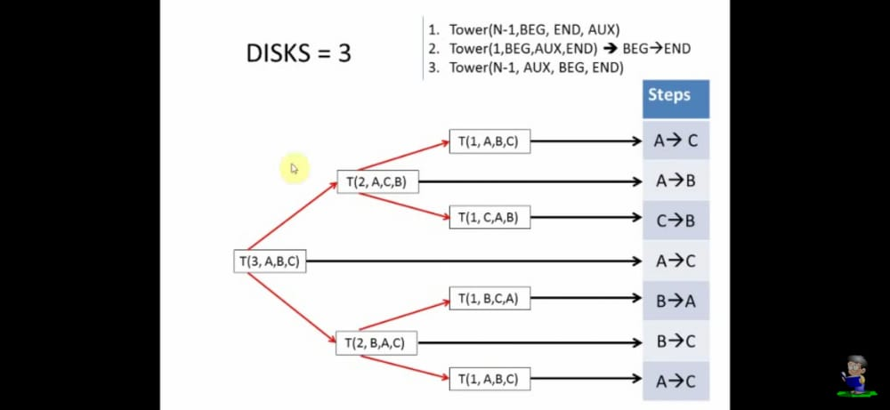](https://youtu.be/8I0mIwVm2f8)

Link To Understand Logic :- <https://youtu.be/8I0mIwVm2f8>

void Hanoi (int n, char A, char C,char B)

{

If(n==0)

{

Return;

}

//recursively move n-1 disks

//from A to B using C as auxx

Hanoi(n-1, A, B, C);

//atomic move of a single disk

printf(“Move 1 disk from %c to %c\n”, A, C);

//recursively move n-1 disks

//from B to C using A as auxx

Hanoi(n-1, B, C, A);

}

Helping Video Link :- <https://youtu.be/hVlqcHY_E5A>

Course link :-<https://onlinecourses.iitk.ac.in/esc101_hindi/#/>